**ERROR 71 HOW TO FIX plz run eve-ng and run putty**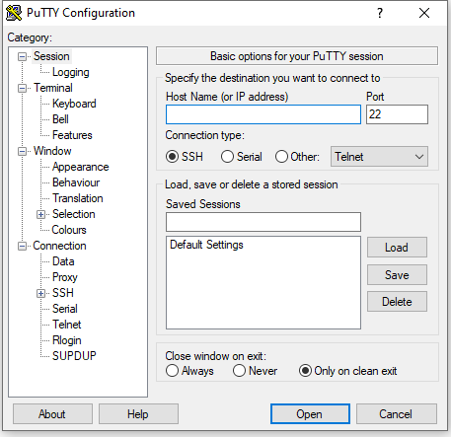

**USE HOSTNAME 192.168.23.60 AND CLICK OPEN** 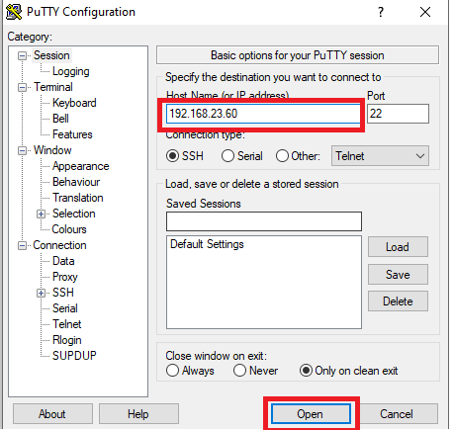

**LOGIN AS: root**

**PASSWORD: eve**

**Then ENTER**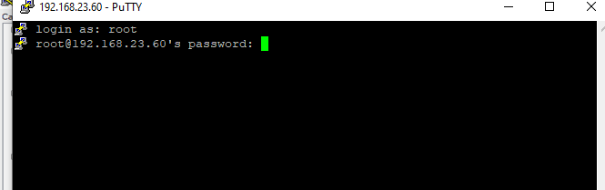

**After enter**

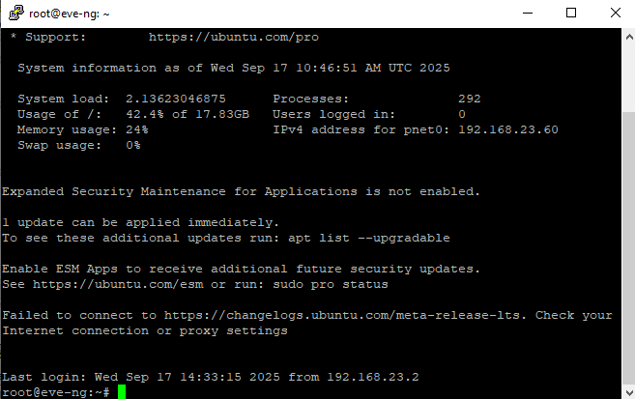

**COMMANDS WRITE WITH CAREFULL 3 commands**

**echo "EVE-NG" > /opt/unetlab/platform**

**chown www-data:www-data /opt/unetlab/platform**

**chmod 644 /opt/unetlab/platform**

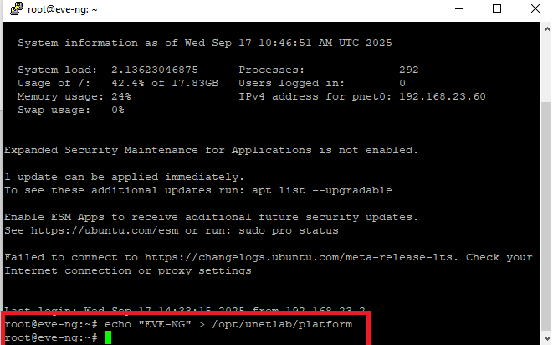

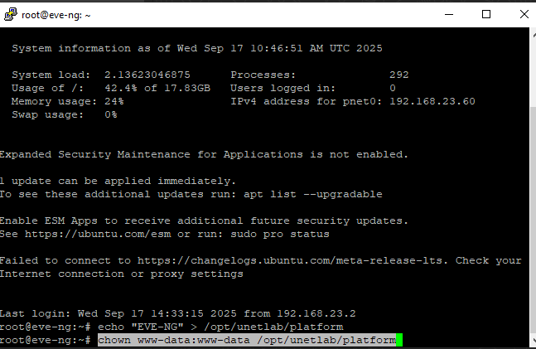

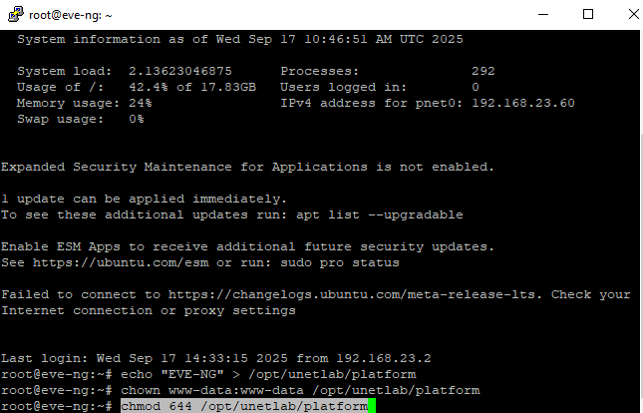

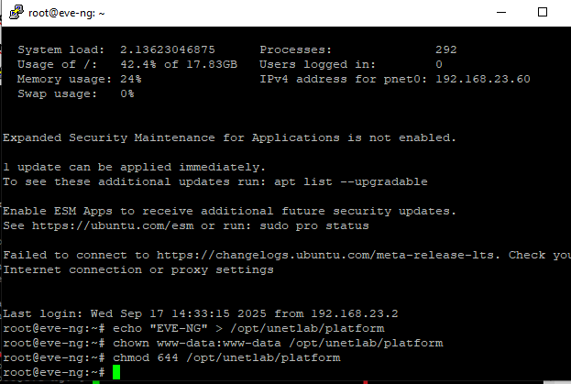

**Go back to eve-ng and do fixpermissions again**

